March Monthly Report

I did not document the followers on the last day of March. Therefore, the change of the number of followers is from 2021/3/4 to 2021/5/6.

On 2021/3/4, there were 31805 followers.

On 2021/5/6, there are 44027 followers.

Since it is almost a year for me to take the weibo blogger position, I created a graph to show the followers change:

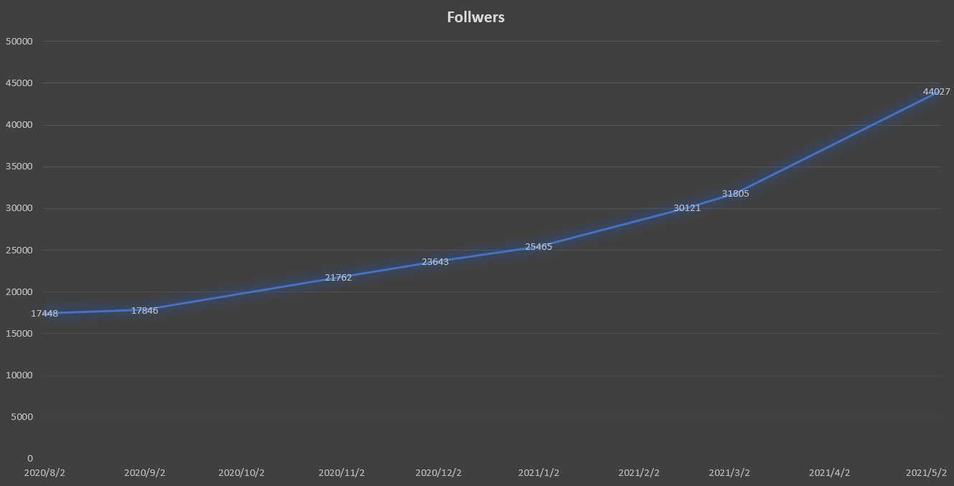

I believe it is because of the covid-19. More Chinese potential applicants seek information from the Internet. And Weibo is still the most popular social media in China.

Attention: This followers change part is the same as the April Monthly Report.

In this month, I finished the #Sweden History# topic. The most important festival in this month should be the Women’s Day, especially in Sweden this country. Therefore, I published some posts about the activities on that day.

Besides that, this month’s posts are very common. The topics are mainly about KTH research or some weather or summer time change. The reposts are about the travel vlog in the holiday before.

March has 31 days. I posted 33 posts. 22 are original and 11 are reposts. On the last day of March, I opened an important series called KTH Admission Count Down. More details are in the April Monthly Report.

Zihan Qiao

2021/5/6 22:00